Task 8.1p

Task 1: Deploying a Networking Layer

**Steps:**

1. Download the **lab-network.yaml** template (defines VPC + public subnet).
2. Open **CloudFormation** → Create Stack → Upload the template.
3. Add **Tag**:
   * Key: application
   * Value: inventory.
4. Deploy and wait for **CREATE_COMPLETE** status.
5. Check:
   * **Resources Tab:** View created VPC and subnet.
   * **Outputs Tab:** View exported values like VPC ID and Subnet ID (used in next task)

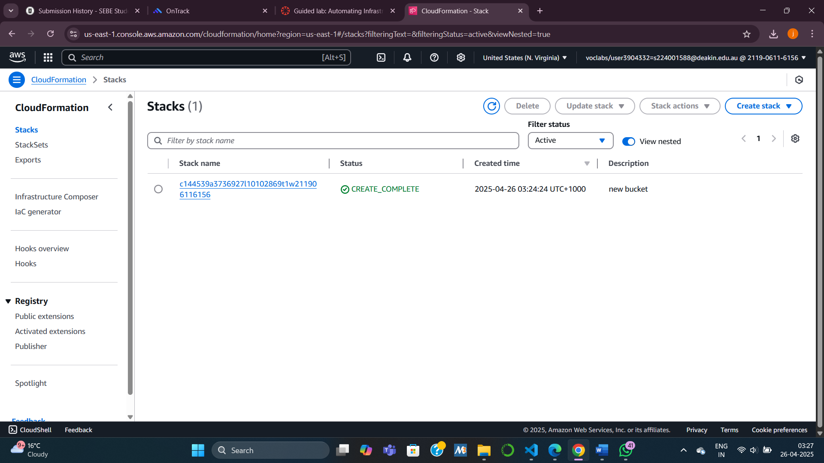

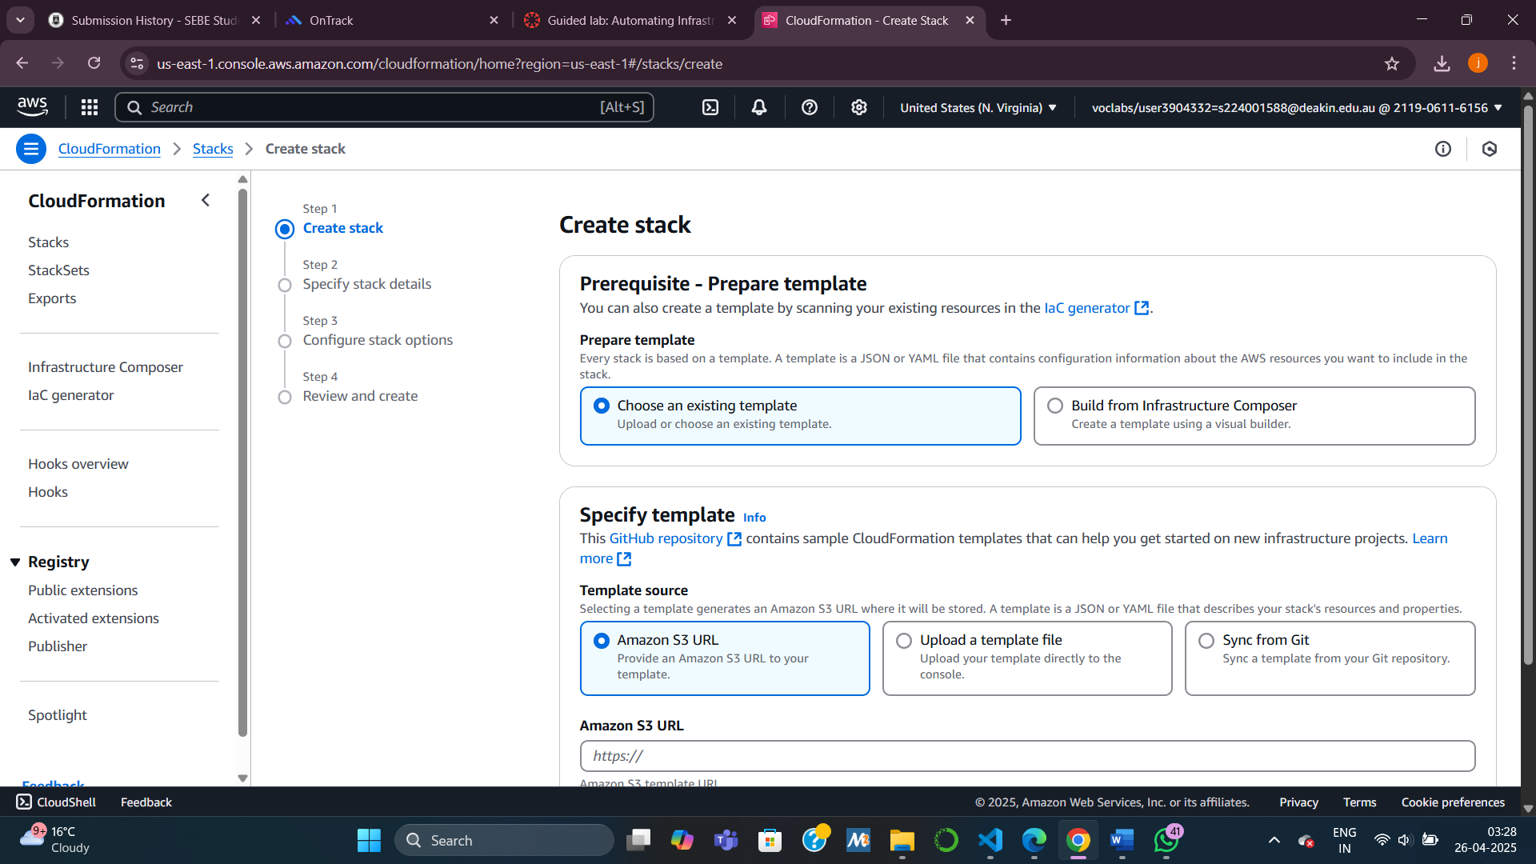

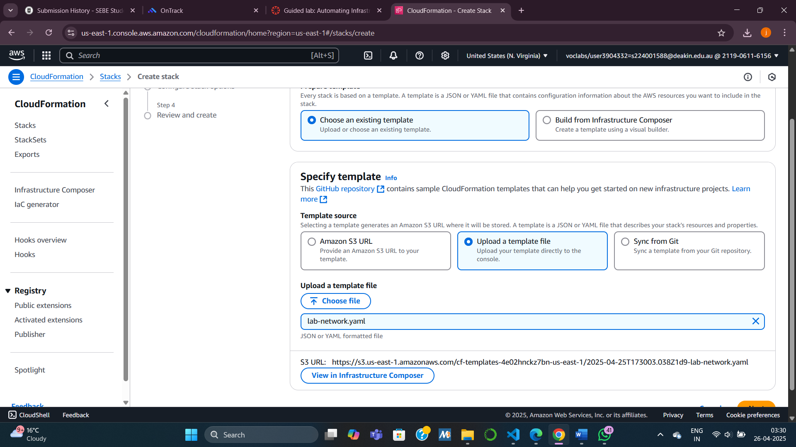

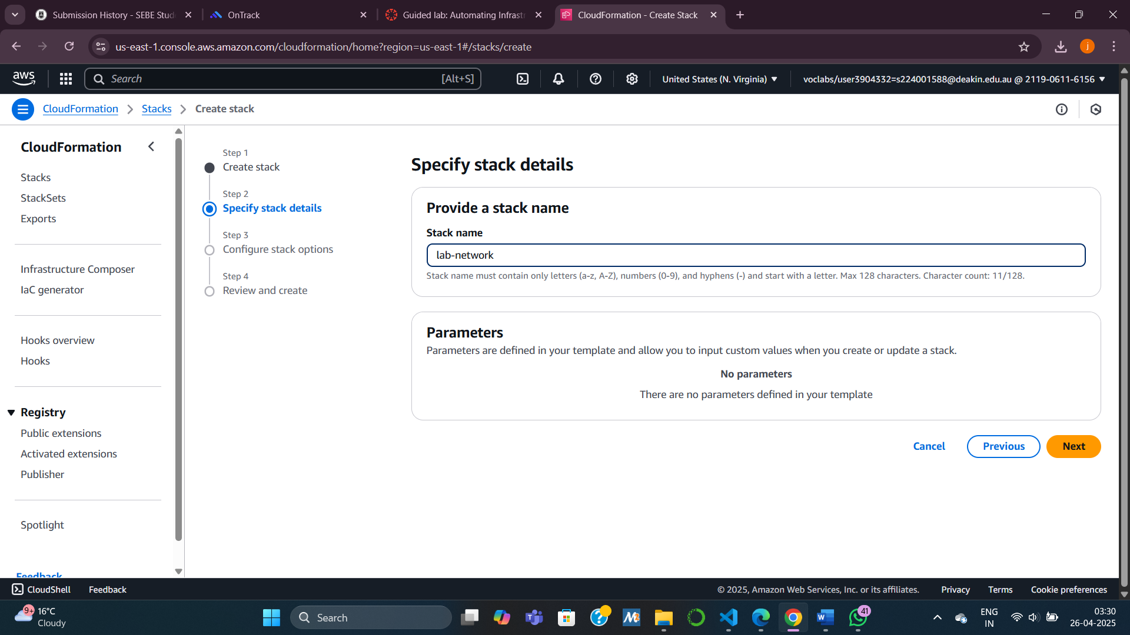

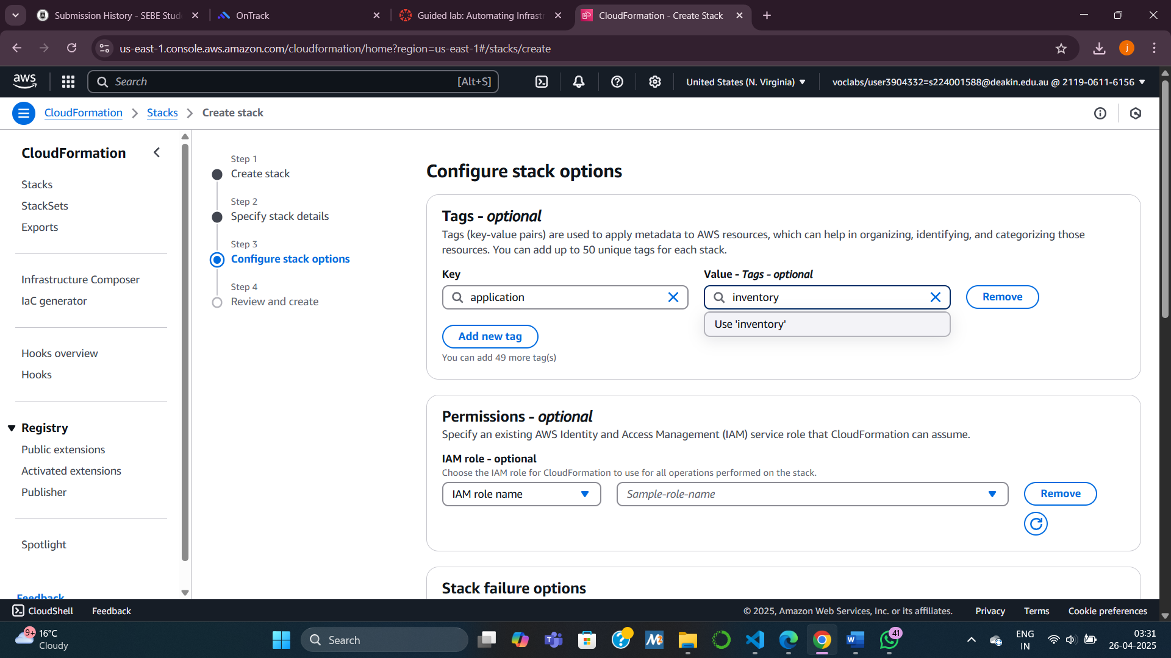

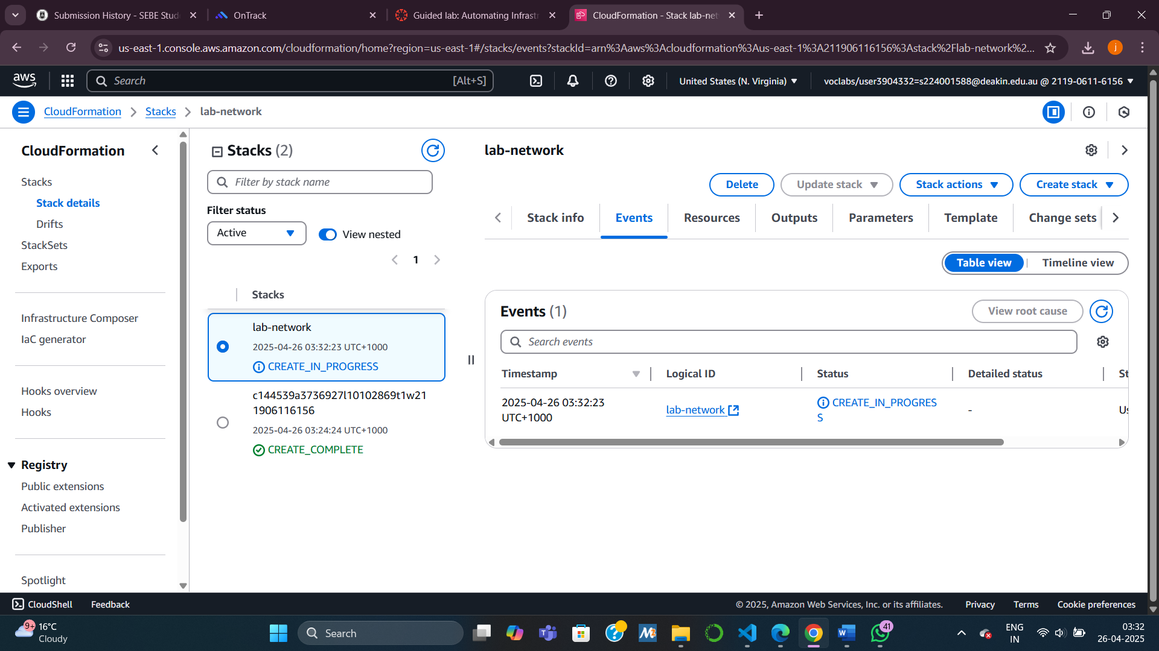

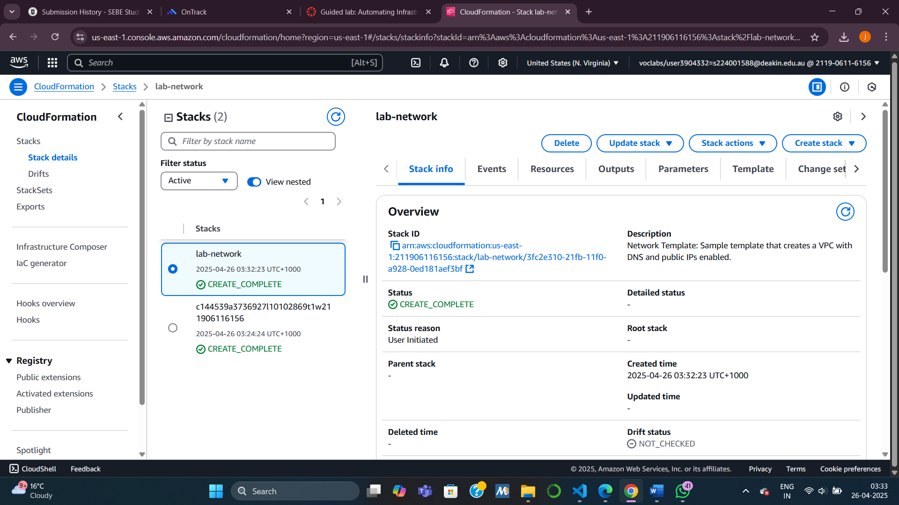

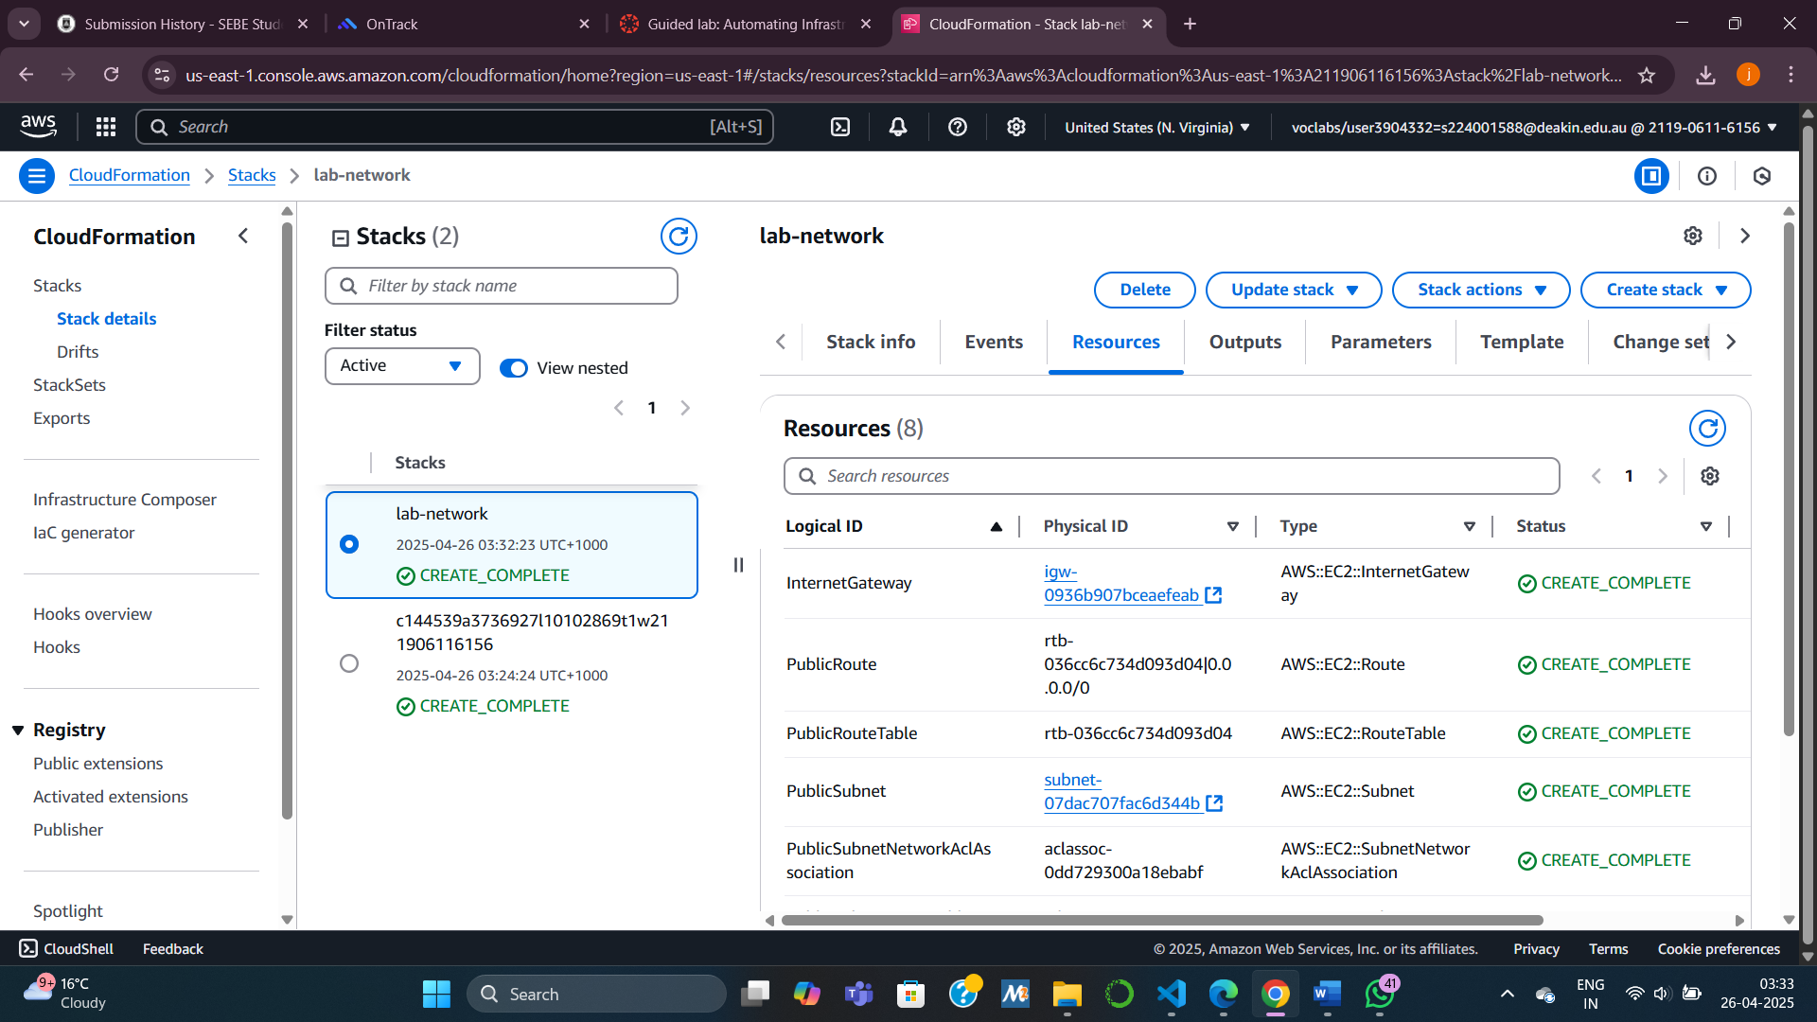

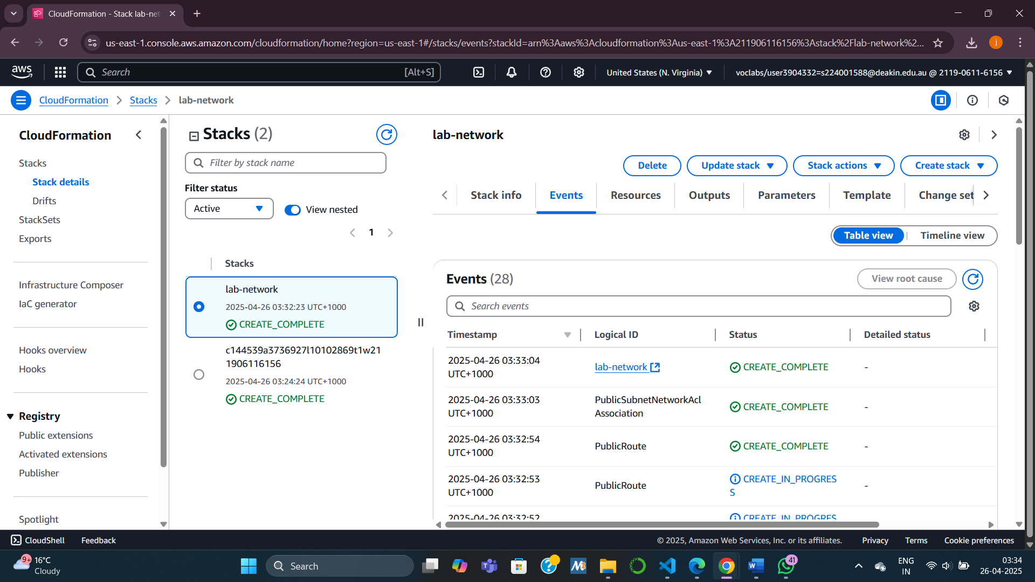

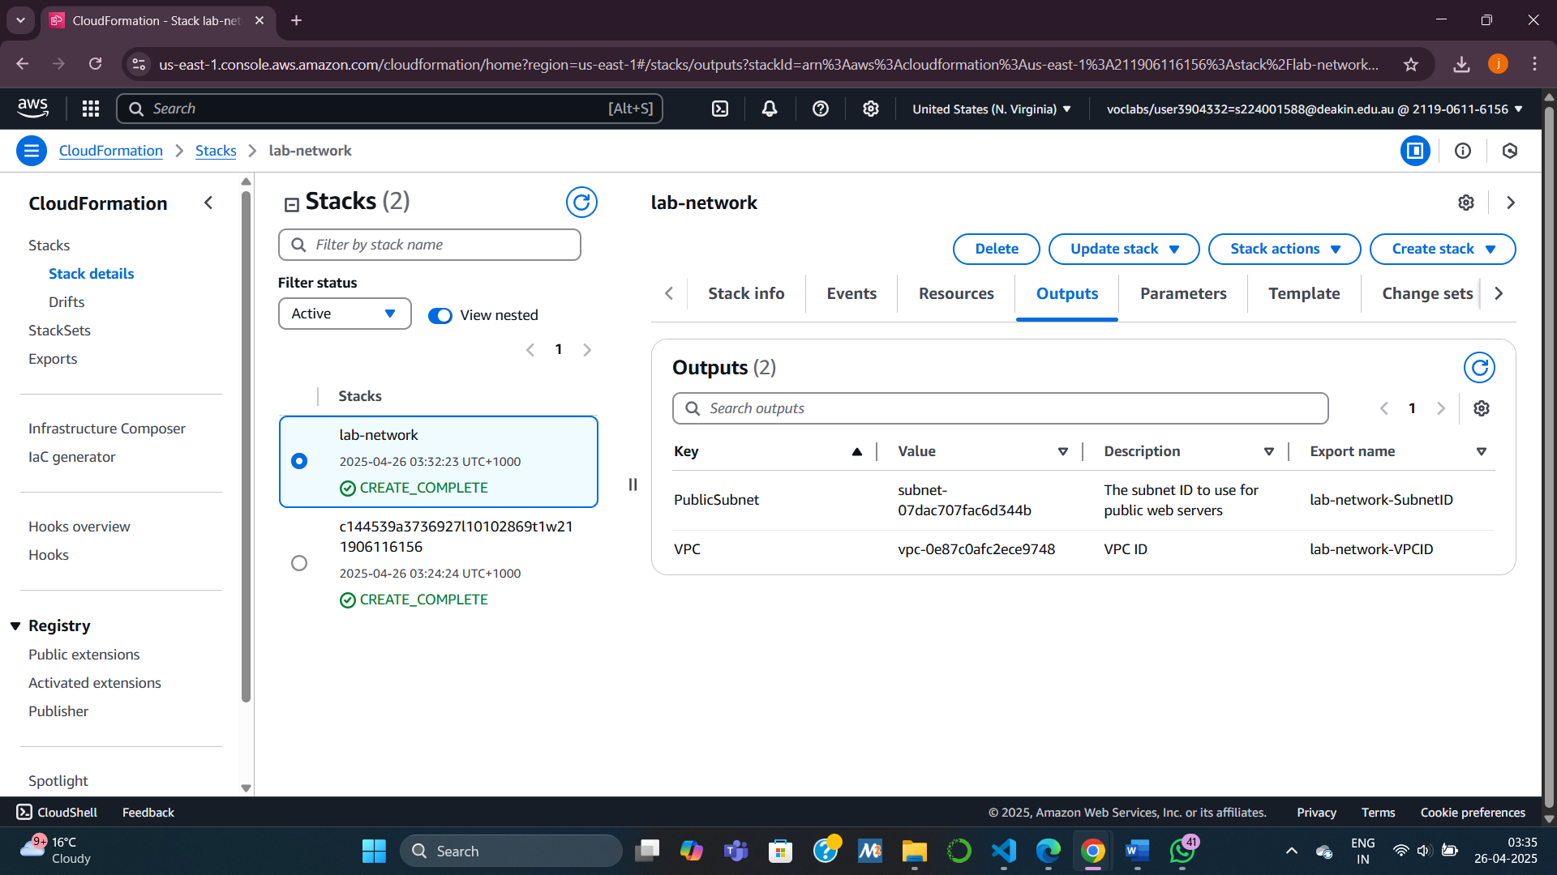

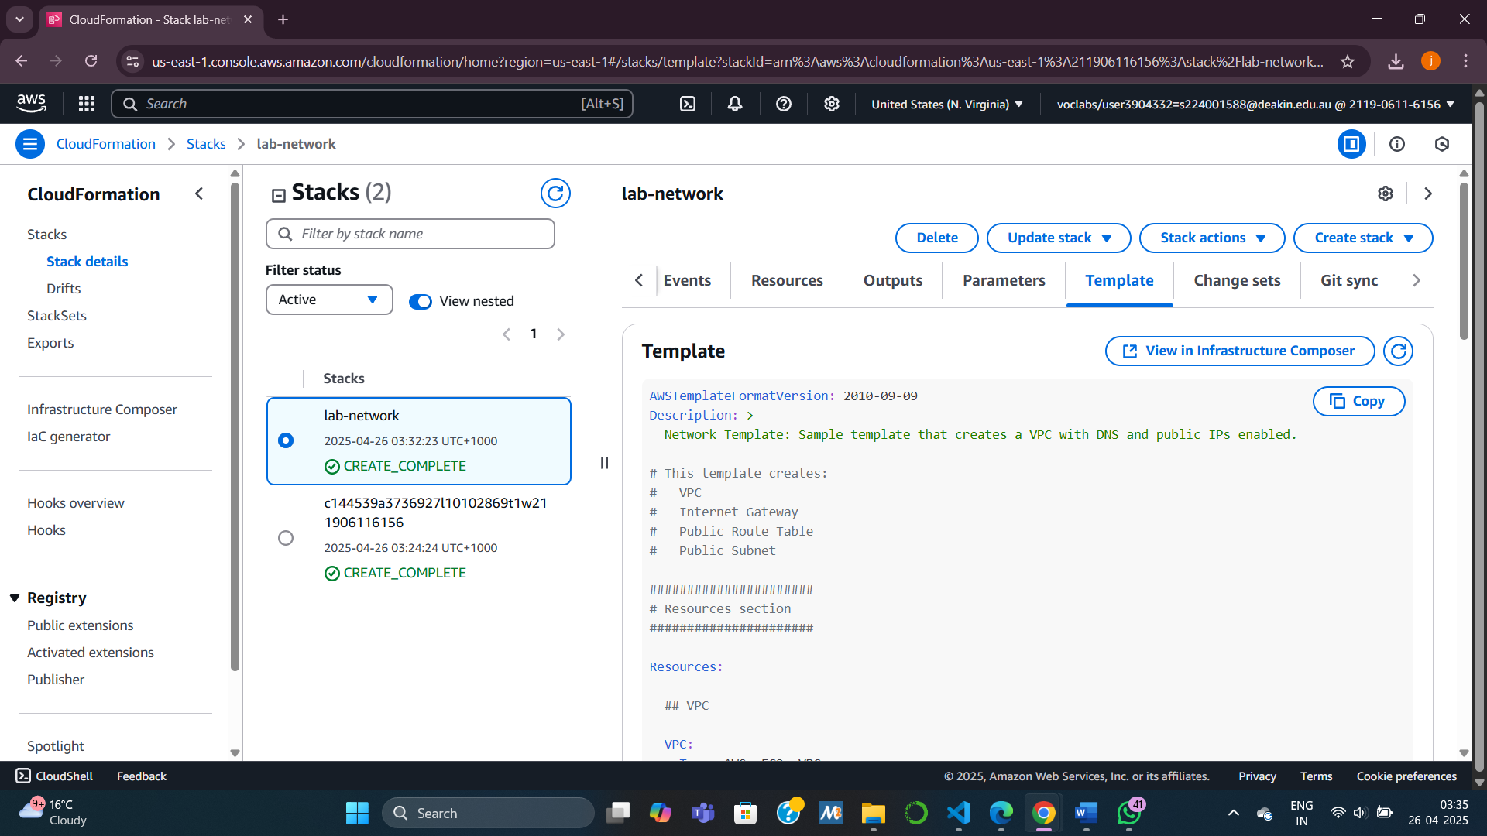

Task 2: Deploying an Application Layer

**Steps:**

1. Download the **lab-application.yaml** template.
2. Create a new stack → Upload the template.
3. Specify NetworkStackName = lab-network (to use outputs from Task 1).
4. Add same **Tag** (application = inventory).
5. Wait for **CREATE_COMPLETE**.
6. Check:
   * **Outputs Tab:** Copy the application URL → Open in browser to verify the EC2 web server.

**Key Concept:**

**Cross-stack reference** — Application stack uses values (like VPC ID, Subnet ID) from the network stack.

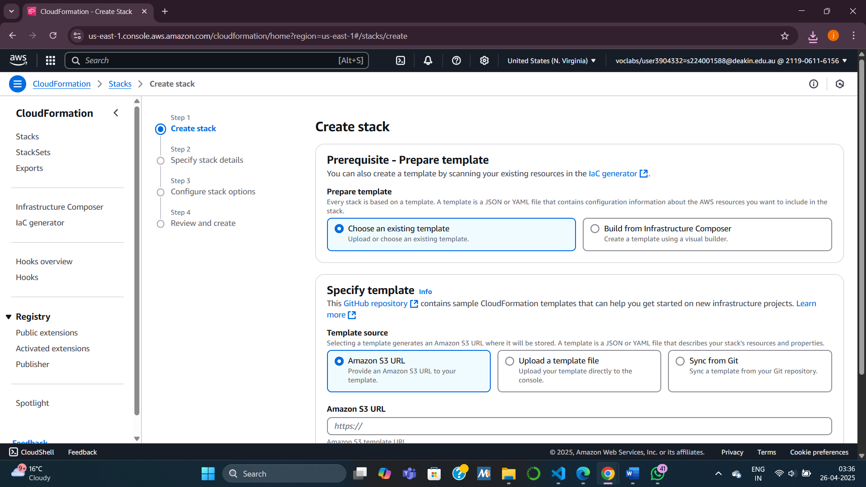

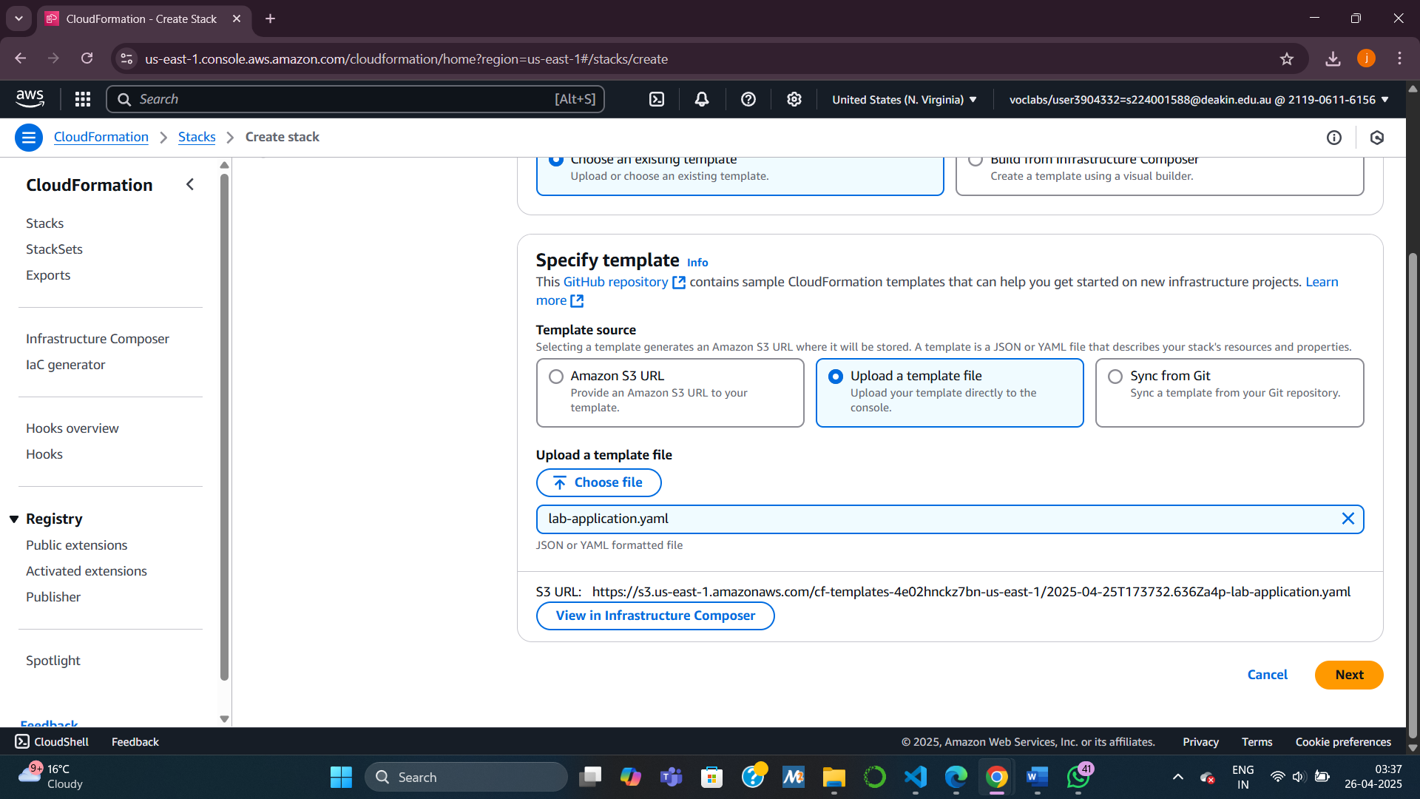

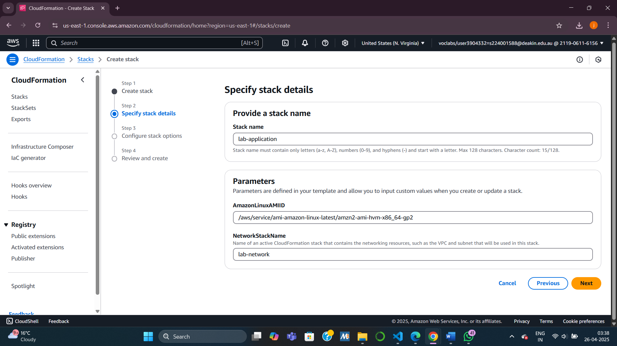

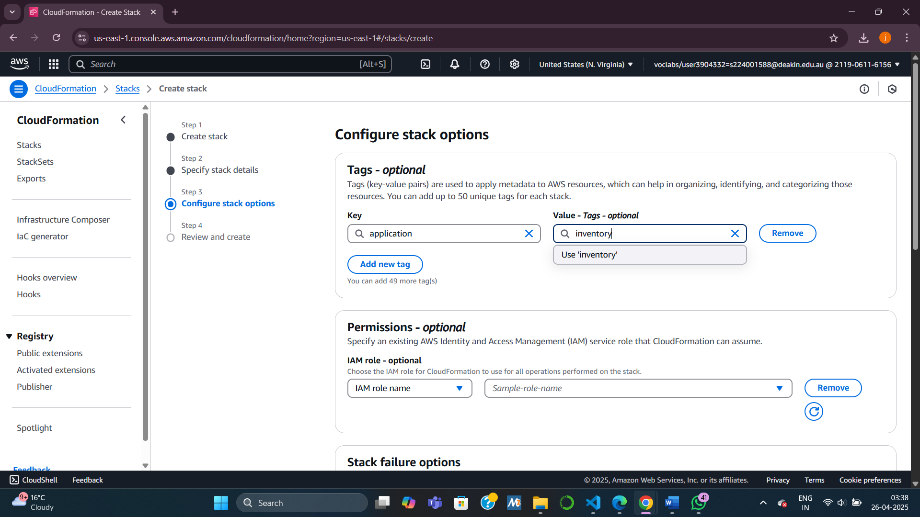

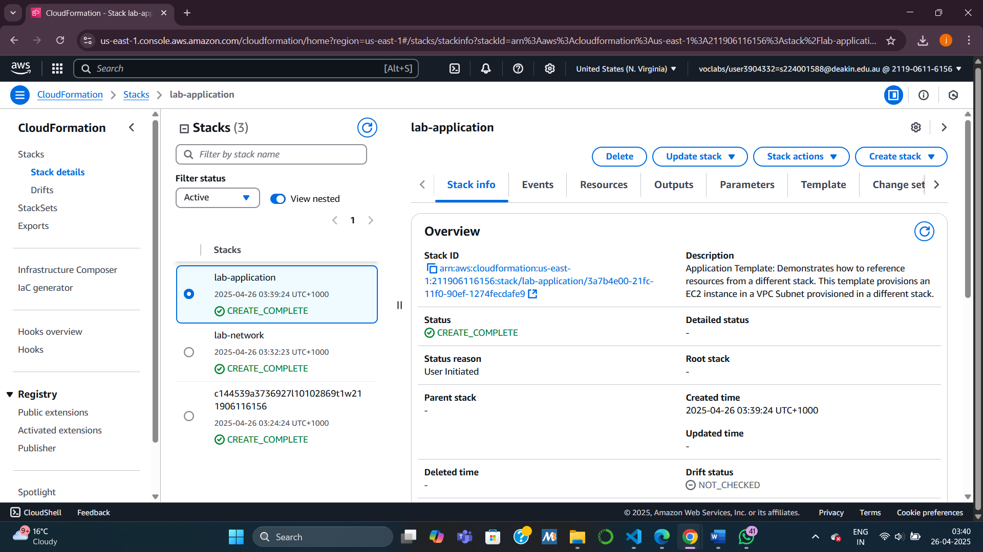

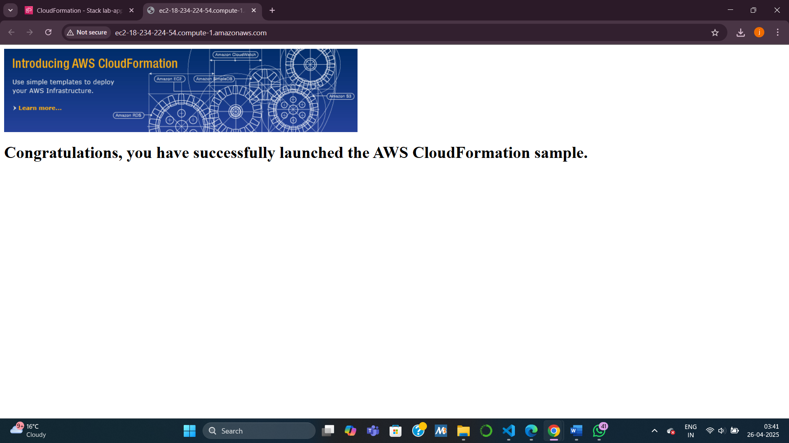

Task 3: Updating a Stack

**Steps:**

1. Check current **inbound rules** (only HTTP allowed).
2. Download **lab-application2.yaml** (includes HTTPS rule).
3. Update the application stack:
   * Choose **Replace current template** → Upload new file.
4. Review **Change Set Preview** (shows what resources will be modified).
5. Wait for **UPDATE_COMPLETE**.
6. Verify in **EC2 → Security Groups → Inbound rules** (now includes HTTPS rule).

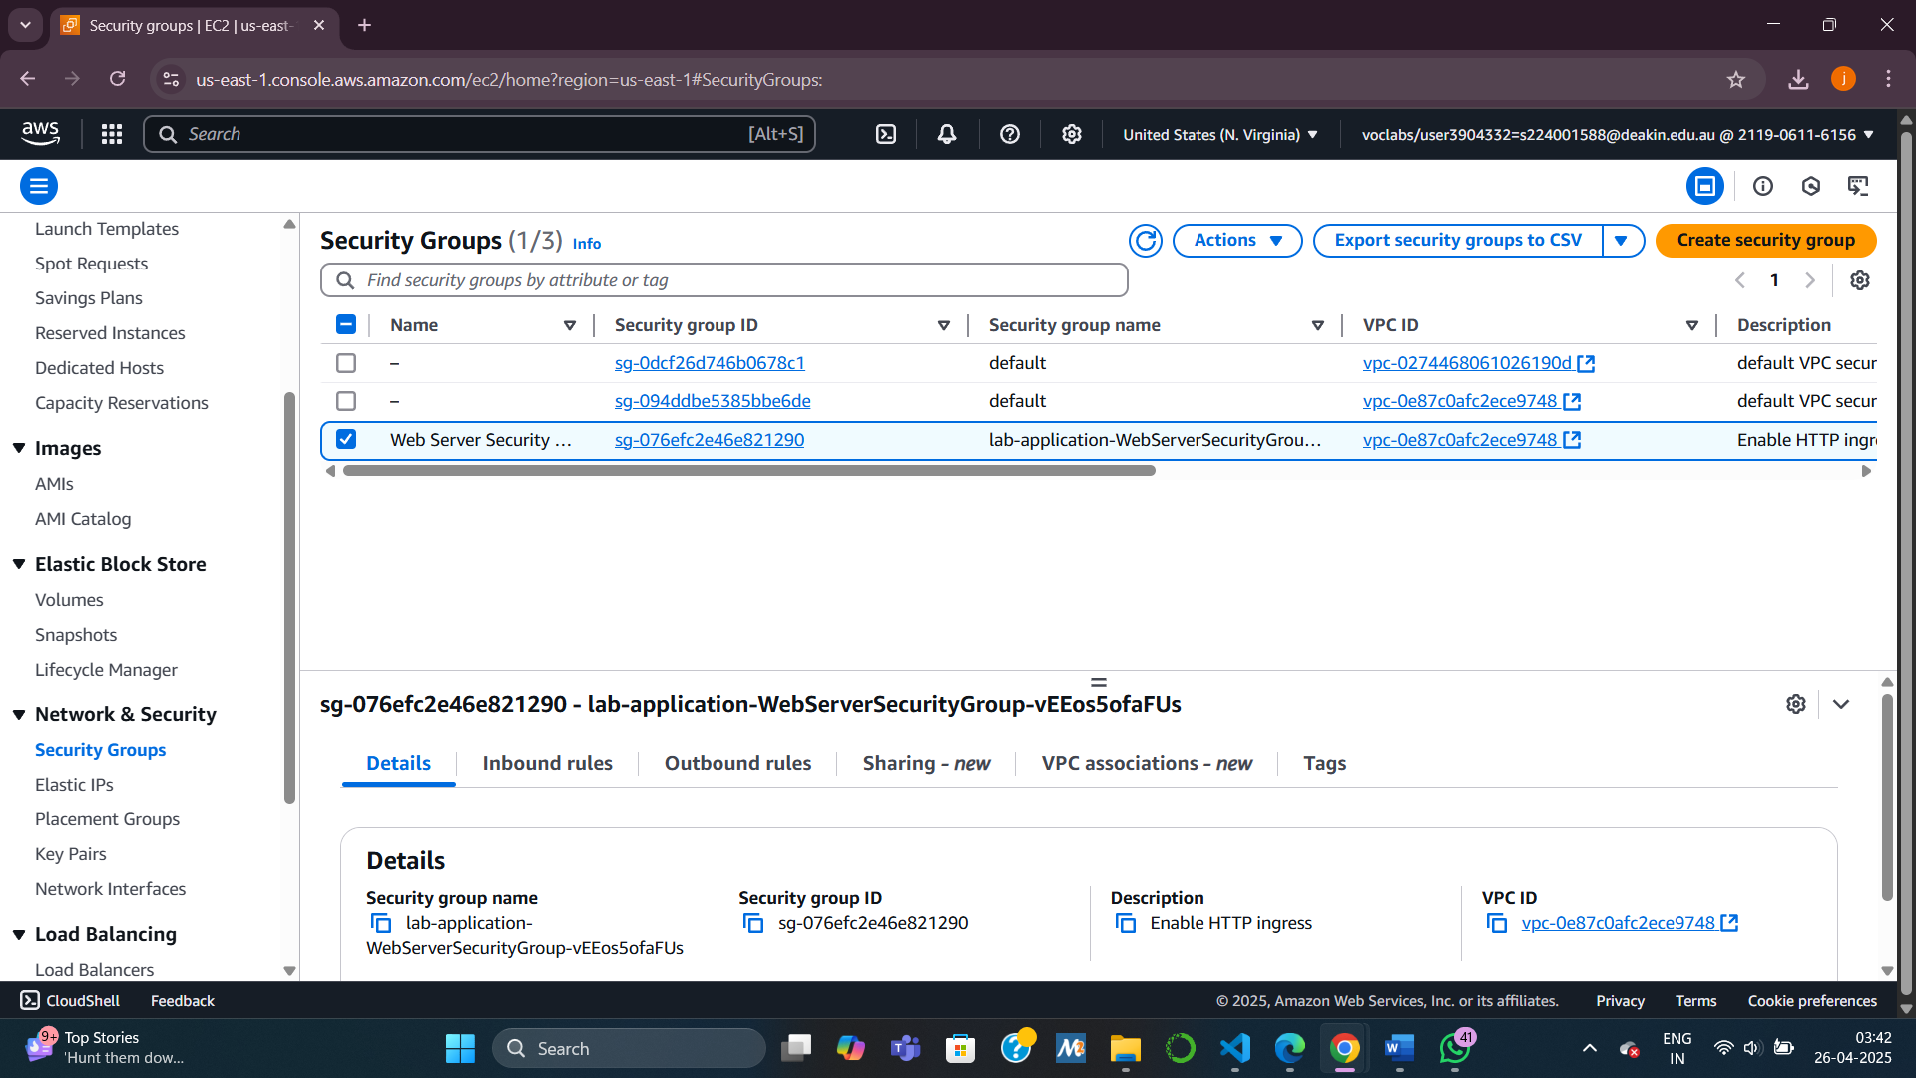

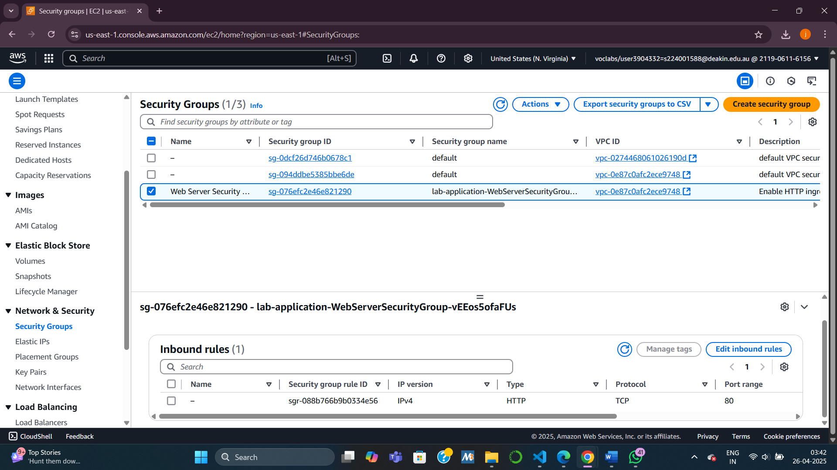

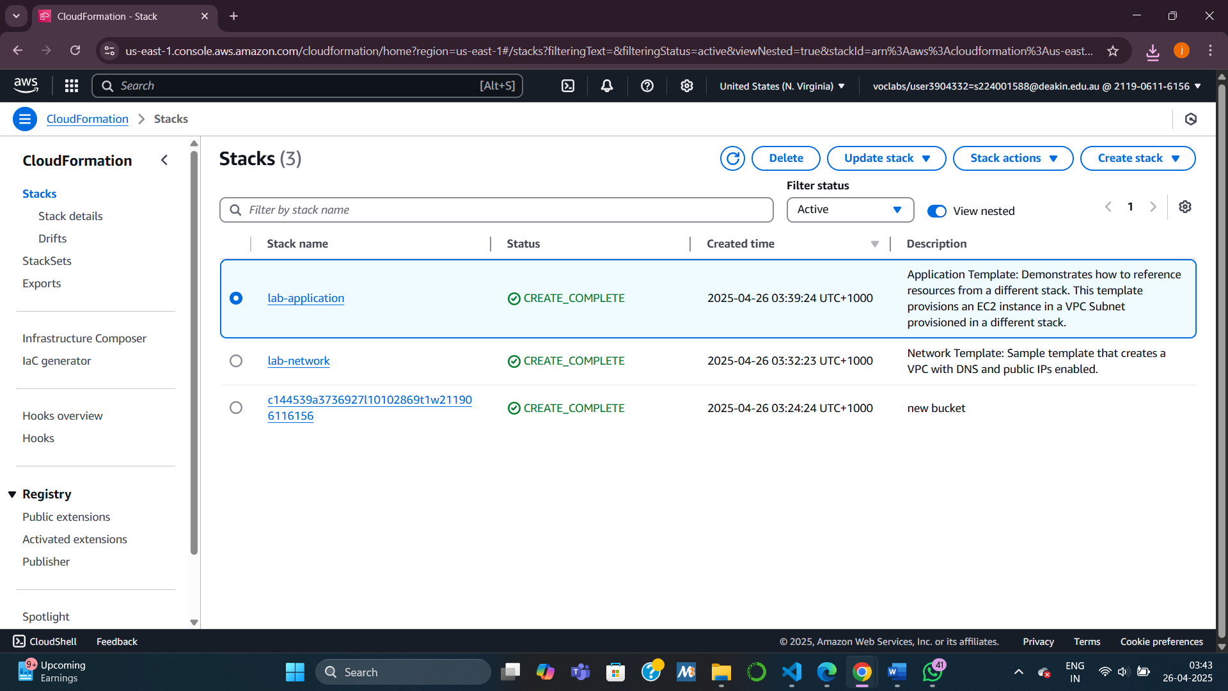

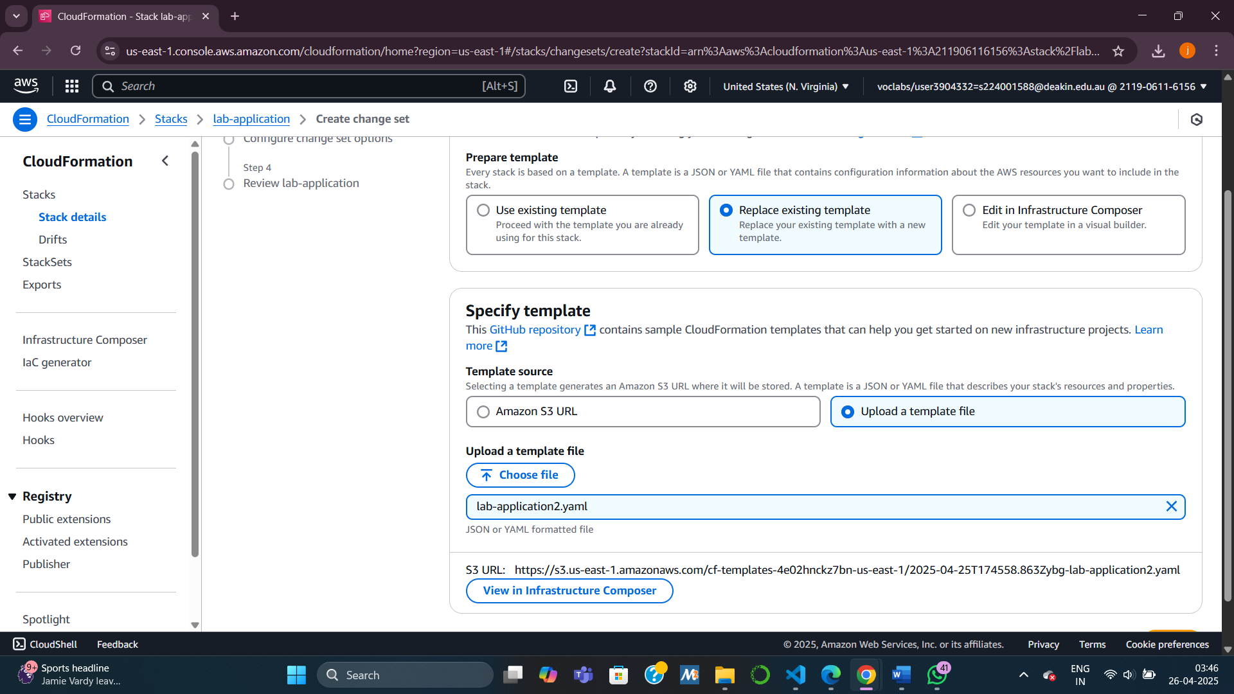

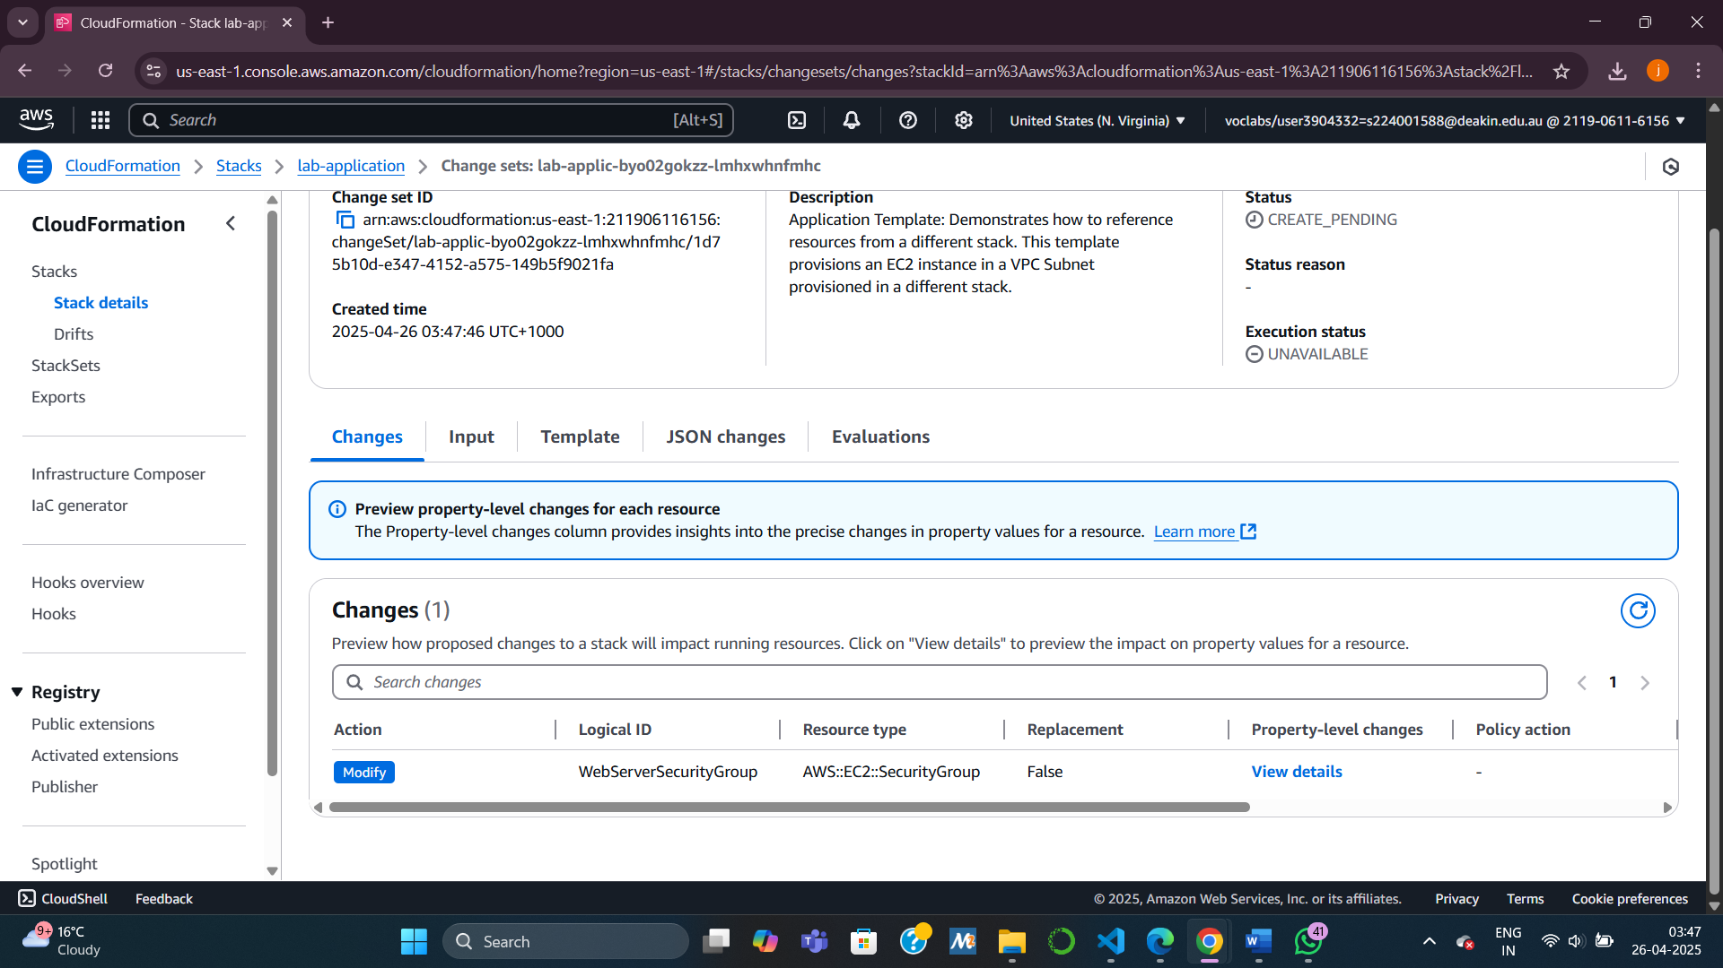

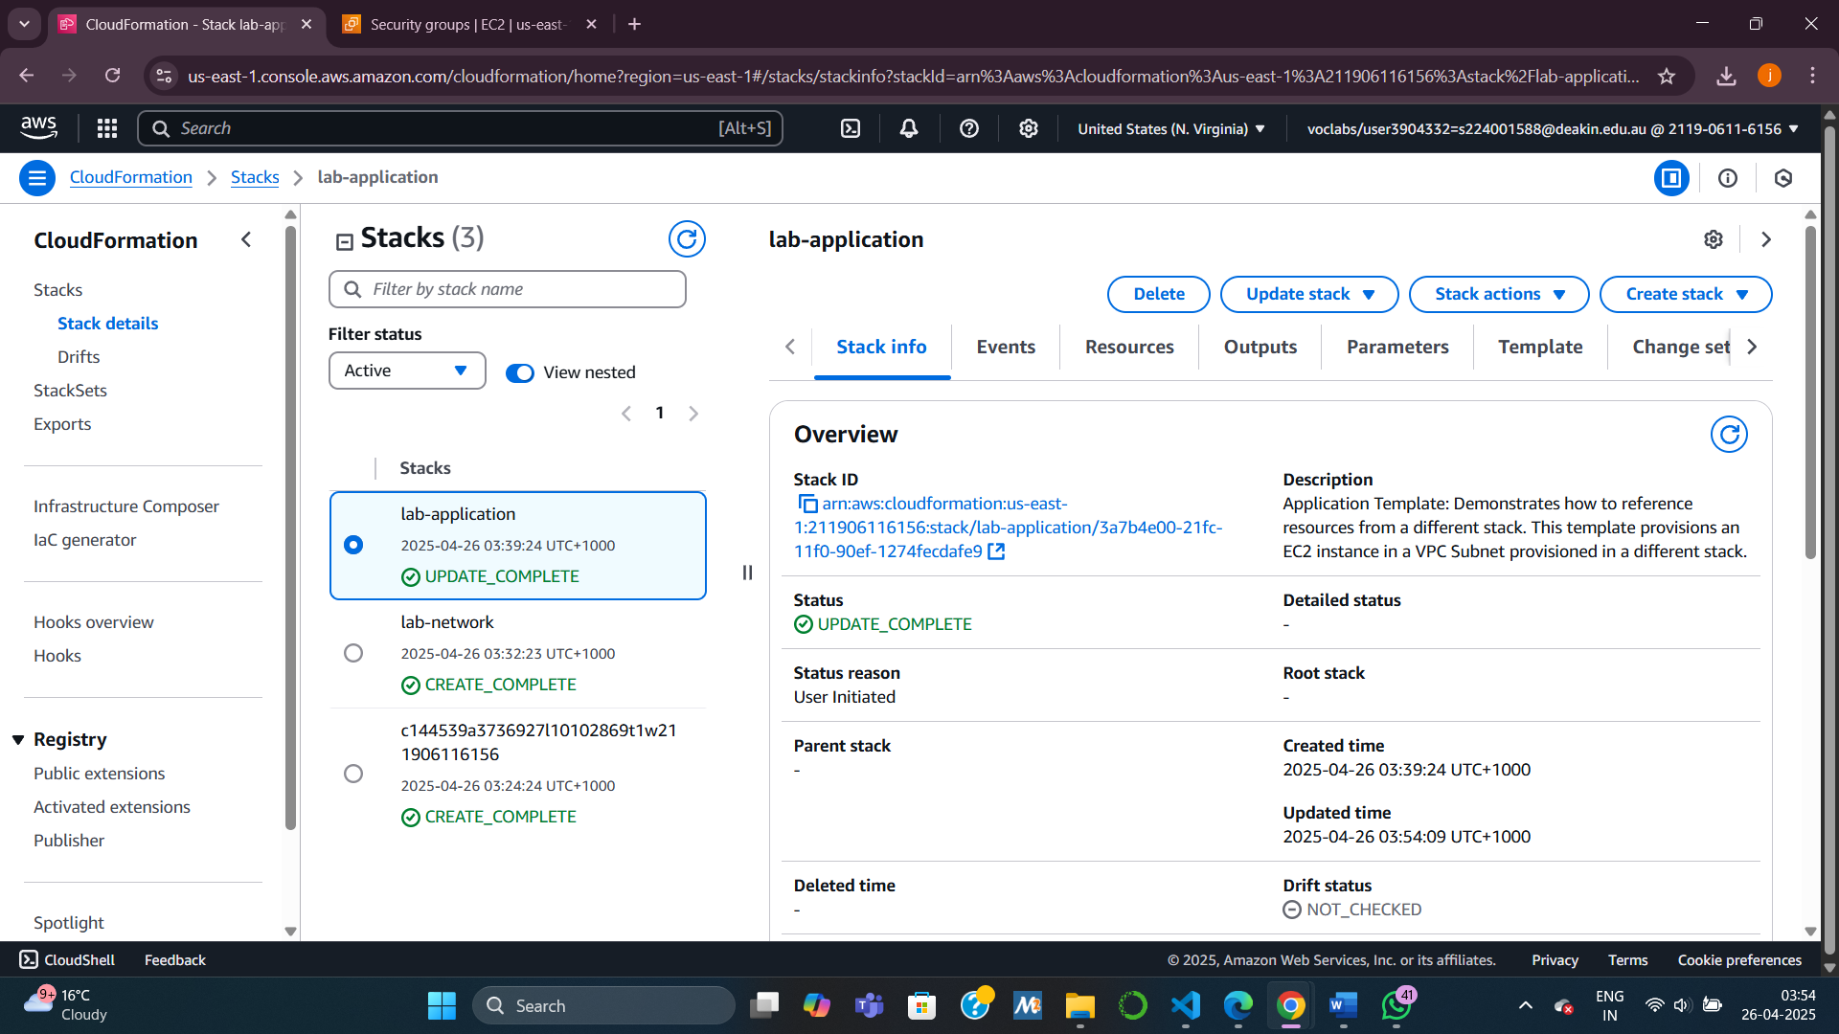

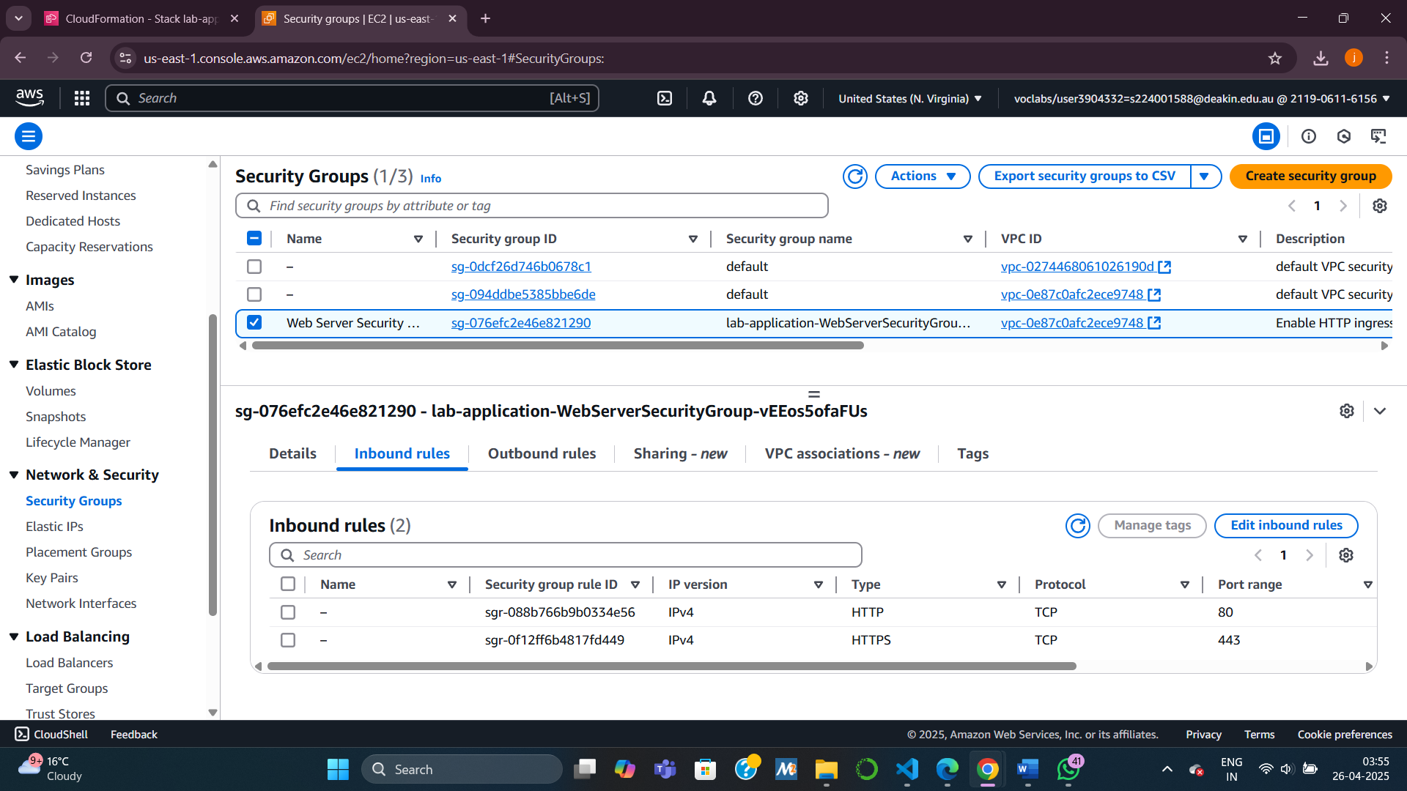

Task 4,: Exploring Templates with AWS CloudFormation Designer

**Steps:**

1. Open **CloudFormation Designer**.
2. Upload **lab-application2.yaml**.
3. View graphical layout of resources and their relationships.
4. Try:
   * Selecting resources → View their YAML/JSON definitions.
   * Dragging new resources into the template.
   * Connecting resources via drag-and-drop.

**Key Concept:**

Visual understanding of template structure helps in **modification** and **troubleshooting.**

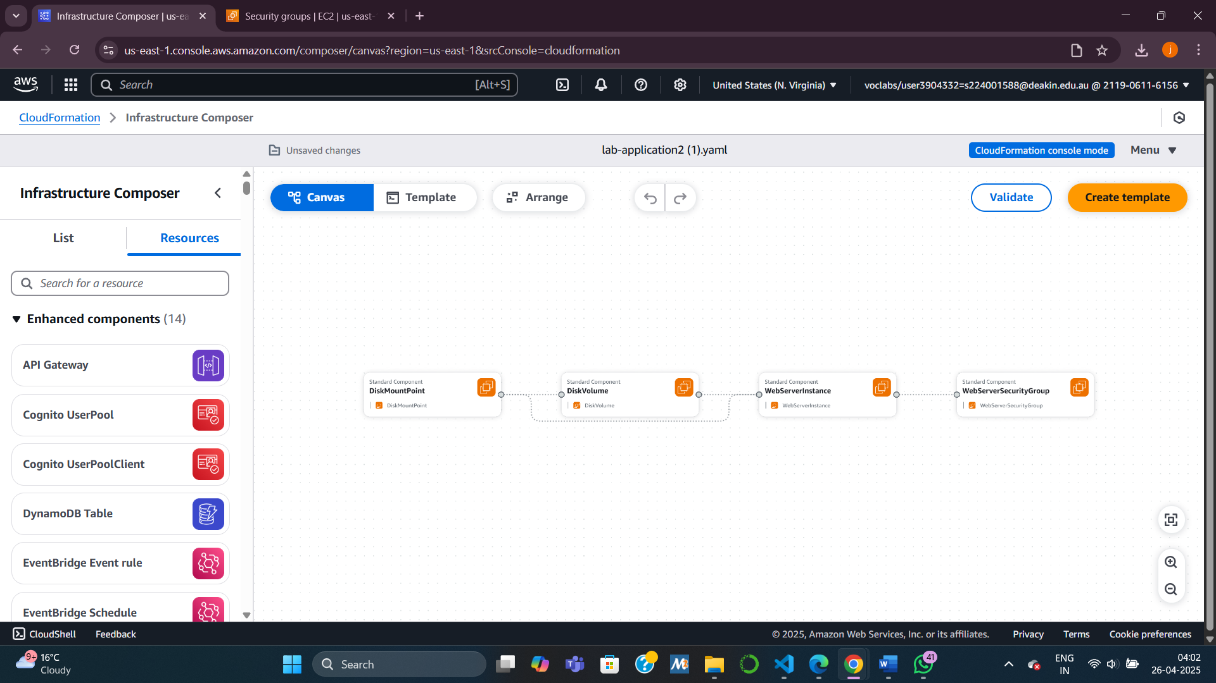

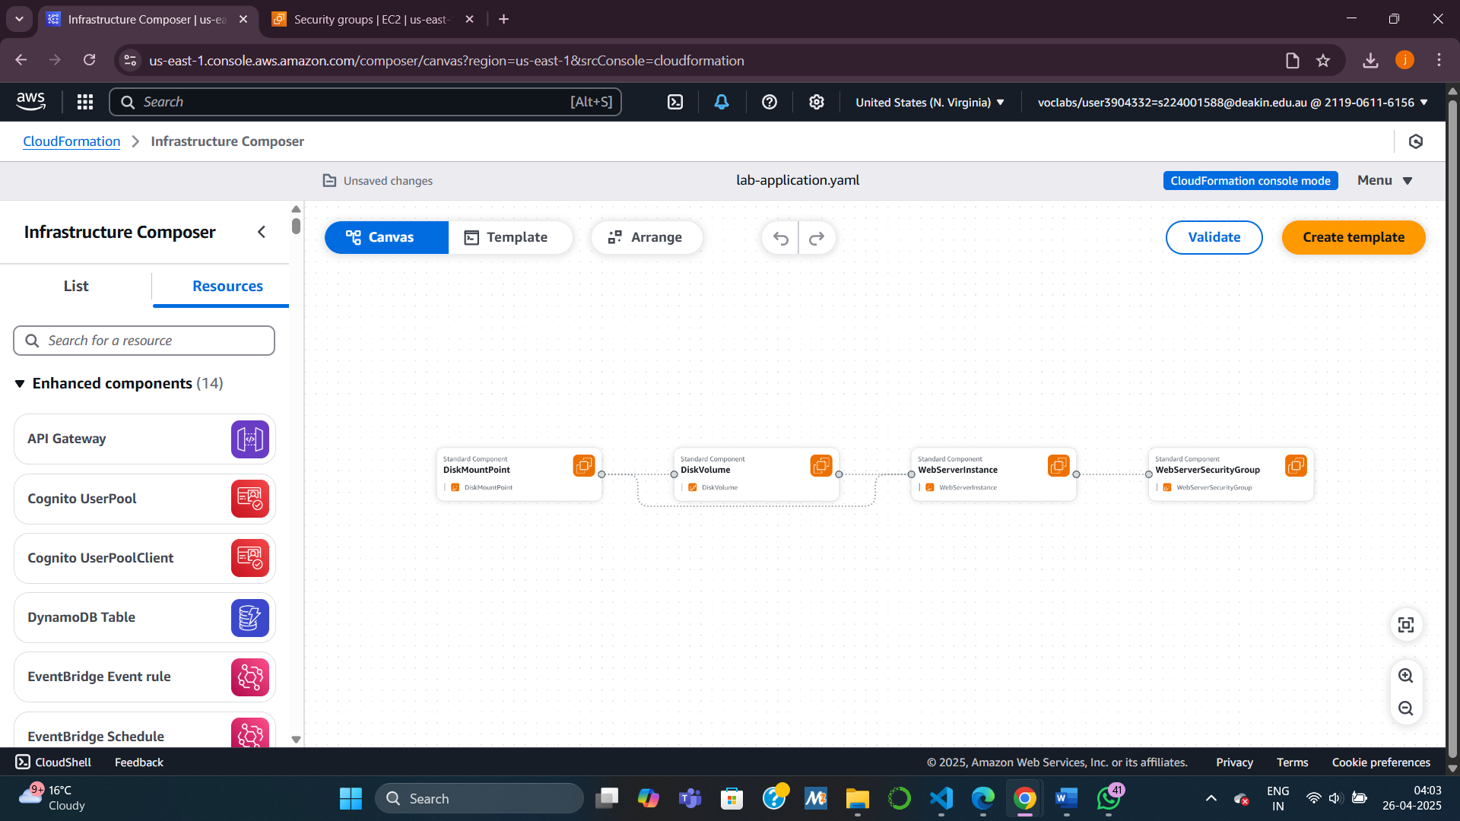

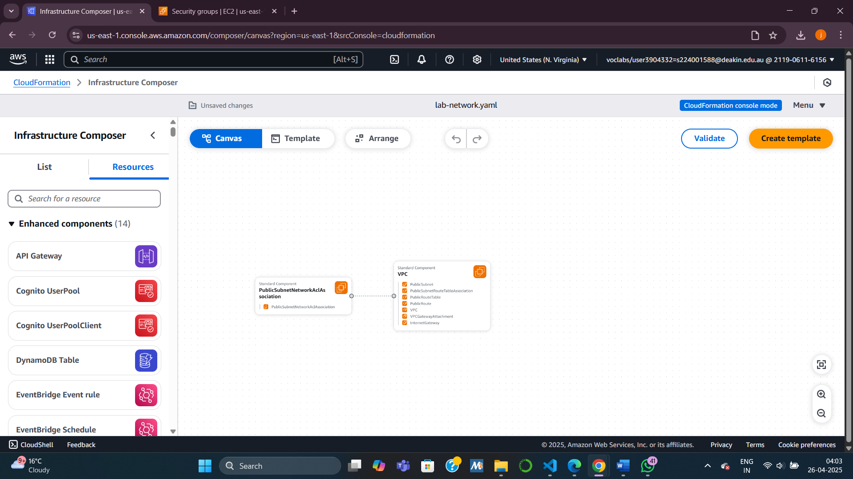

Task 5: Deleting the Stack

**Steps:**

1. Delete the **lab-application** stack via CloudFormation.
2. Stack removes resources **except** for the EBS snapshot (due to DeletionPolicy: Snapshot).
3. Verify:
   * Open **EC2 → Snapshots**.
   * Check for the **Web Data** snapshot (status: Completed).

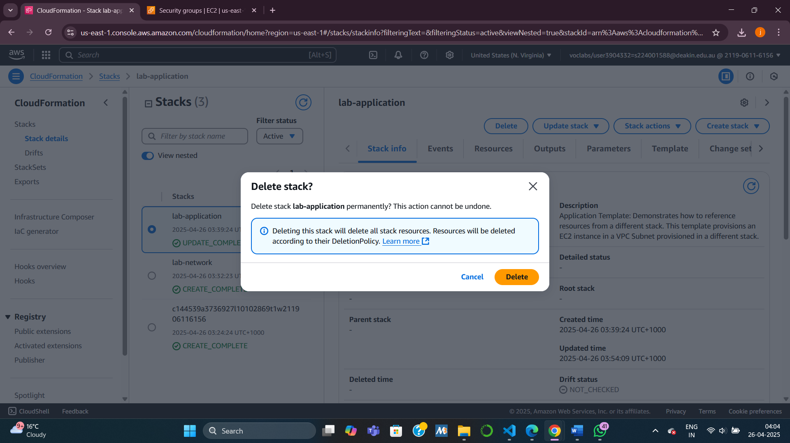

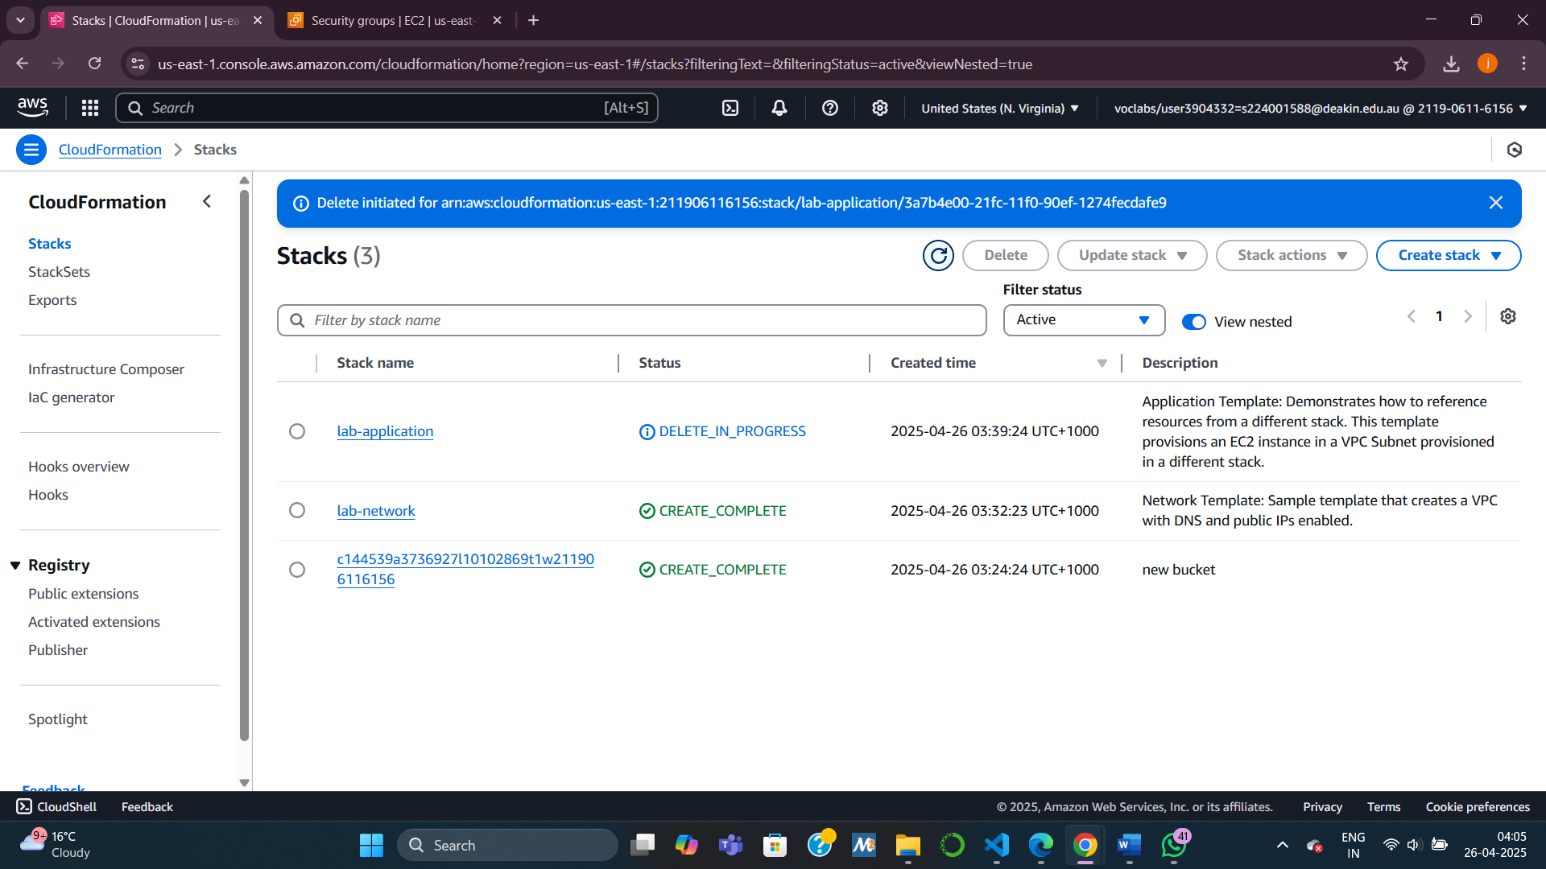

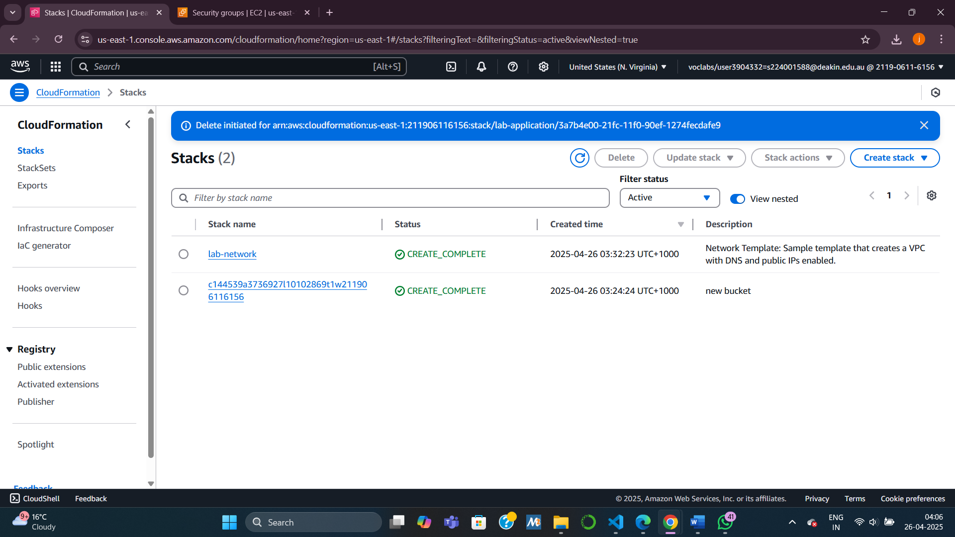

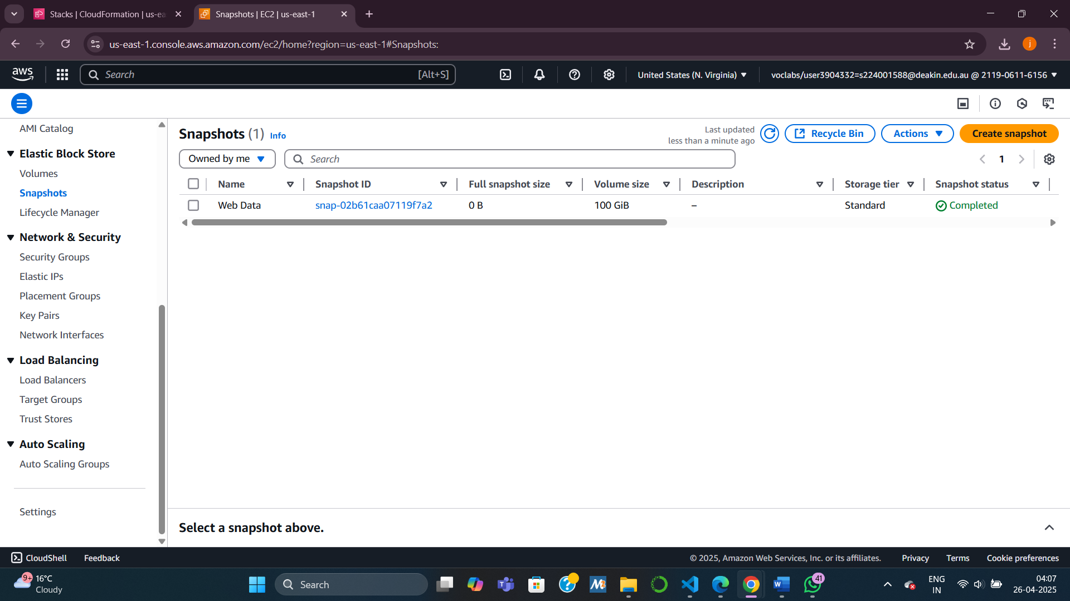

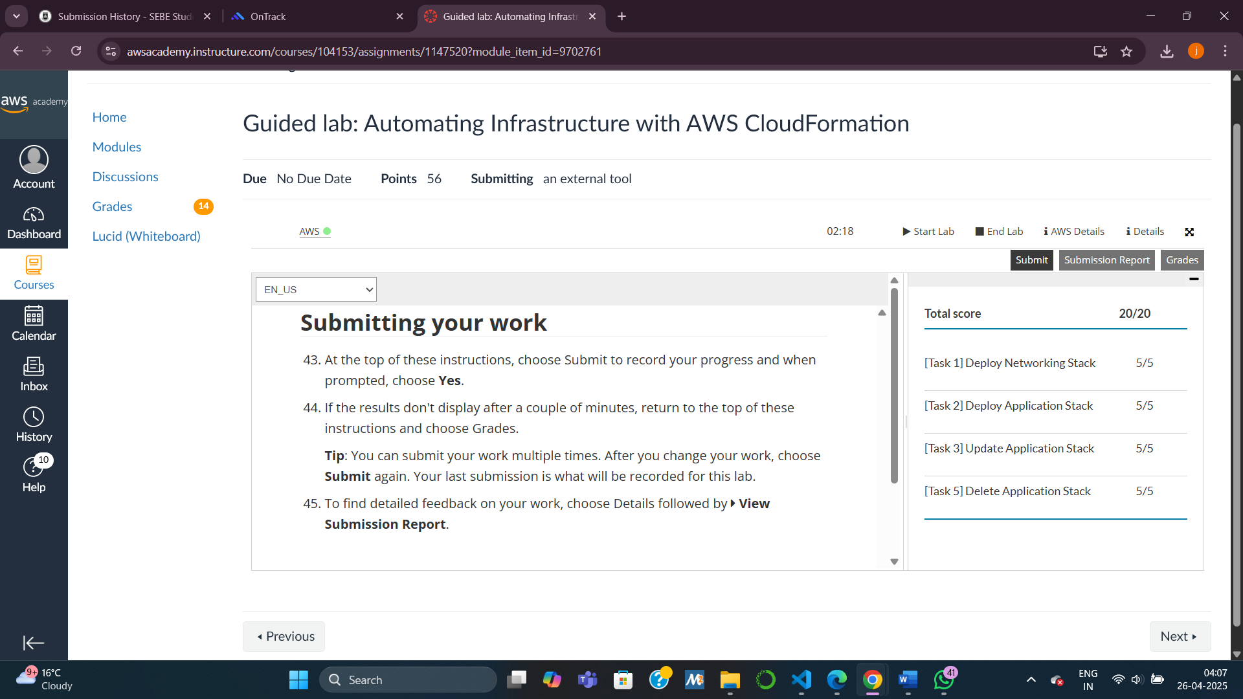

Knowledge check

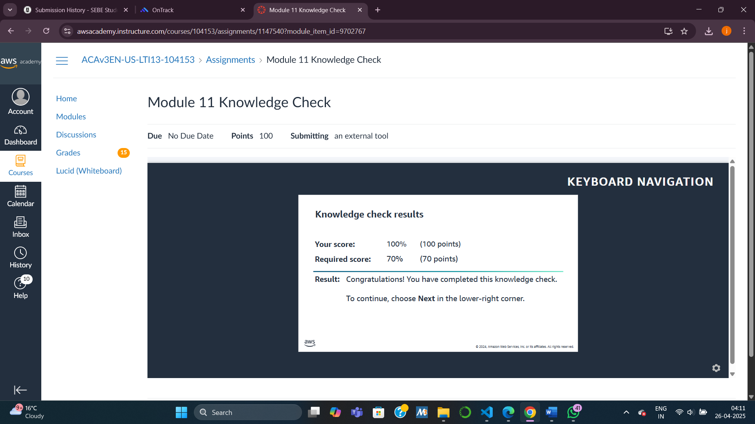

Task questions:

**1. How do you export a value from one stack and import into another stack?**

* In CloudFormation, you can export values from one stack using the Outputs section with an Export name.
* Another stack can import these values using the intrinsic function Fn::ImportValue.
* This allows stacks to share resource information like VPC IDs, Subnet IDs, or Security Group IDs across different templates securely and efficiently.

2. If you want to retain an EBS disk after deleting the CloudFormation template, what should you do?

* Use the DeletionPolicy: Snapshot attribute in the CloudFormation template for the EBS volume resource.
* This tells CloudFormation to create a snapshot of the EBS volume instead of deleting the data when the stack is removed.
* This approach ensures that your data is backed up as a snapshot, even if the stack and the EBS volume are deleted.

**3. Give 2 examples of CloudFormation intrinsic functions and explain what they do.**

|  |  |  |
| --- | --- | --- |
| Function | Purpose | Example |
| !Ref | Returns the **physical ID** or the value of a resource or parameter. | VpcId: !Ref MyVPC returns the ID of the VPC created in the template. |
| Fn::Join | Concatenates a list of strings into a **single string** with a specified delimiter. | Fn::Join [":", ["sg", "12345"]] → result: sg:12345. Useful for combining resource names, ARNs, etc. |

Other commonly used functions include:

* **Fn::GetAtt** – gets an attribute of a resource (e.g., an instance’s Public IP).
* **Fn::Sub** – substitutes variables into strings.